SOFTWARE DESIGN DOCUMENT
Project: Serverless Task Automation Platform
Architecture: Client–Server with Modular Monolith Backend
GitHub: https://github.com/Harii-rm/serverless-task-automation-platform

1. Introduction
1.1 Purpose
This document presents the software design of the Serverless Task Automation Platform. It explains the architectural structure, modular organization, UI design strategy, and major technical decisions made to ensure maintainability, scalability, and clean code structure.

2. Design Principles Applied
2.1 Abstraction
Abstraction is applied by separating high-level rule management from low-level execution mechanics.
- Users interact with automation rules.
- Internal scheduling logic is hidden.
- Execution handling is abstracted through service modules.
- Controllers abstract HTTP routing from business logic.
This reduces complexity visible to users and isolates technical details.
2.2 Modularity
The backend is implemented as a modular monolith with distinct modules:
- Authentication Module
- Rule Management Module
- Trigger Module
- Action Module
- Scheduler Module
- Logging Module
- Data Access Module
Each module exists independently within the backend and performs a single responsibility.
2.3 High Cohesion
Each module performs one clearly defined task:
- Rule Module → Handles rule lifecycle
- Scheduler → Handles timed execution
- Logging → Handles execution tracking
- Auth → Handles authentication logic
This ensures internal consistency and easier testing.
2.4 Low Coupling
Low coupling is achieved through:
- Separation of UI and backend
- Service layer between controllers and models
- Database logic isolated in repository layer
- Scheduler interacting through service interface only
Changes in UI do not impact business logic.
Database changes minimally affect higher layers.

3. High-Level Architecture
3.1 Architecture Style Chosen
The system follows a Client–Server architecture in which the frontend web interface acts as the client and communicates with a centralized Flask backend that processes requests and manages business logic. The backend is implemented as a Modular Monolithic application, meaning it is deployed as a single unit but internally organized into well-defined modules such as authentication, rule management, scheduling, and logging. This approach ensures simplicity in deployment while maintaining clear separation of responsibilities, high cohesion within modules, and low coupling between components. It provides a stable and maintainable structure suitable for the project’s scale without introducing unnecessary distributed system complexity.
3.2 Why This Architecture Was Chosen
The system is designed as a web-based automation platform with a single deployable backend service.
Microservices were not chosen because:
- The system is small-to-medium scale.
- No independent service scaling is required.
- A single database is used.
- Simplicity improves maintainability.
The modular monolith approach allows internal separation of responsibilities without introducing distributed system complexity.
3.2 Updated Architecture Diagram
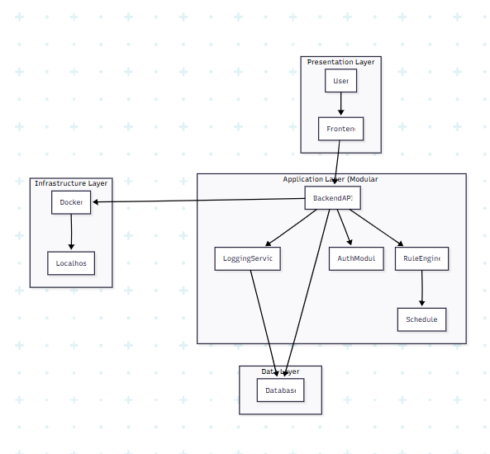
4. Key Design Decisions & Justification
4.1 Use of Modular Monolithic Architecture
The system is implemented as a modular monolithic backend within a client–server structure. Since the project is medium-scale and does not require distributed services, a monolith keeps deployment simple while still allowing internal separation of modules. Logical separation of authentication, rule management, scheduling, and logging improves maintainability without introducing unnecessary microservice complexity.

4.2 Separation of Business Logic from Controllers
The Rule Engine is separated from Flask route handlers to ensure clear separation of concerns. Controllers manage HTTP requests, while services handle business logic. This improves testability, readability, and reduces coupling between routing and core execution logic.

4.3 Dedicated Scheduler Module
The scheduler is implemented as an independent module responsible for trigger monitoring and task execution. This improves cohesion by isolating timing logic and allows future enhancement or replacement of scheduling mechanisms without affecting other modules.

4.4 Docker-Based Deployment
Docker is used to ensure consistent runtime environments and reproducible builds. Containerization simplifies setup, avoids dependency conflicts, and aligns the project with modern deployment practices.

4.5 Centralized Logging Service
A dedicated logging service records execution results and errors. Separating logging from rule execution improves system observability and keeps execution logic clean and focused.

5. User Interface
1]LOGIN
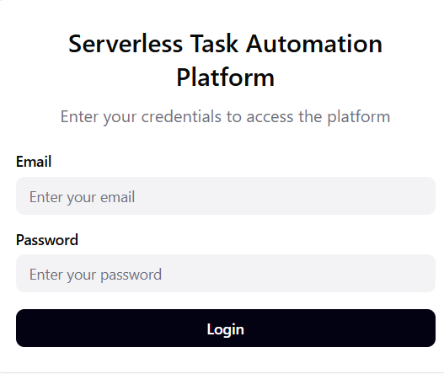
2]Dashboard
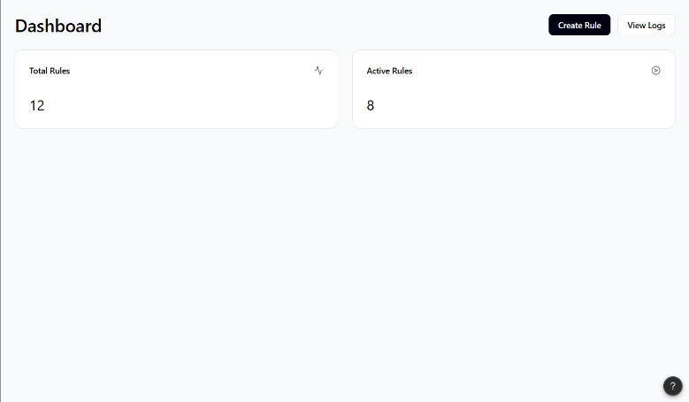
3] Execution Logs
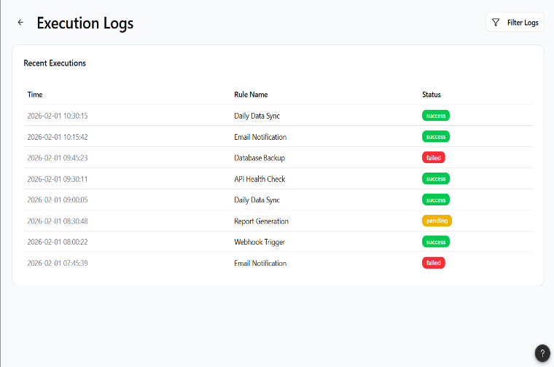

4] Create Automation Rule
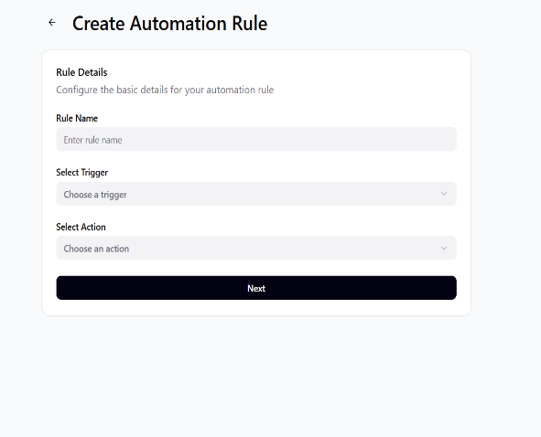
5] Trigger Config
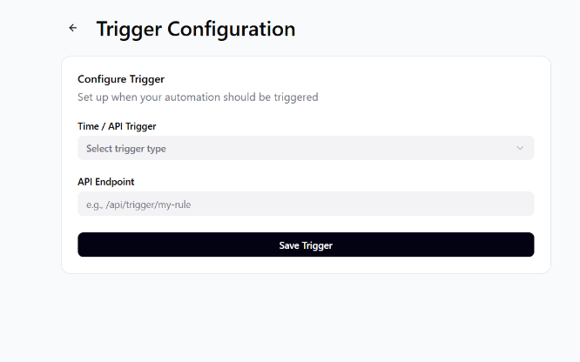
6] Action config
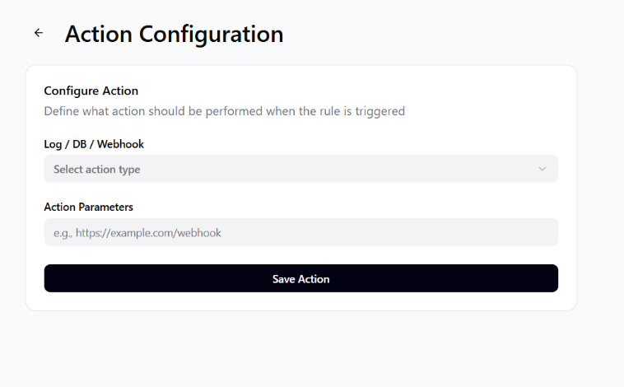

The user interface was designed with a strong focus on simplicity, clarity, and consistency to ensure a user-friendly experience. A clean layout with clearly labeled buttons and input fields was maintained across all screens to provide visual consistency. Primary actions such as “Create Rule,” “Save,” and “Execute” are prominently placed to guide users intuitively through the workflow. Forms are structured step-by-step (rule creation → trigger configuration → action configuration), reducing cognitive overload and making the automation process easy to follow. Clear feedback messages are provided for successful actions and errors, ensuring users understand system responses immediately. The dashboard presents summarized information such as active rules and execution logs in an organized manner, improving visibility and control. Overall, the interface prioritizes ease of navigation, minimal clutter, and logical flow to enhance usability.

